Silas Caporal • Lionel DeLuna

Masson Lopez • Mohammad Sufyaan • Morgan Germany

10/02/2024

ITAI 1378

Professor: Patricia McManus

A06 TensorFlow Playground

The site TensorFlow Playground is like using computers with brains. These computers can process information. TensorFlow is a computer program that was inspired to work as our brains work. Just like our brains get information from our senses, a neural network gets it’s information from inputted data.

This system uses tiny bits of codes called “neurons” which are connected in layers. Neurons are the building blocks. Data is passed through the layer(s) of neurons, the data is processed, and then decide what to do next. Neurons do the calculations and pass the information along. There's usually an input layer, hidden layers, and an output layer. These networks give a result, like a prediction or a decision. [2]

When the activation functions are set, these activation functions act like the rules that tell a neuron whether to fire or not. Different activation functions might have slightly different behaviors, but overall, they control the neuron’s output based on the input. The weights and biases control how strong the connections are between neurons. When training the network, we essentially are teaching a neural network with lots of examples, and tell it the right answers. The network adjusts its weights and biases to get better and better at making correct predictions. [2]

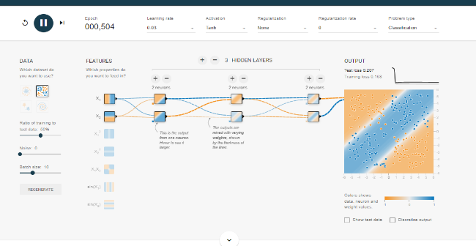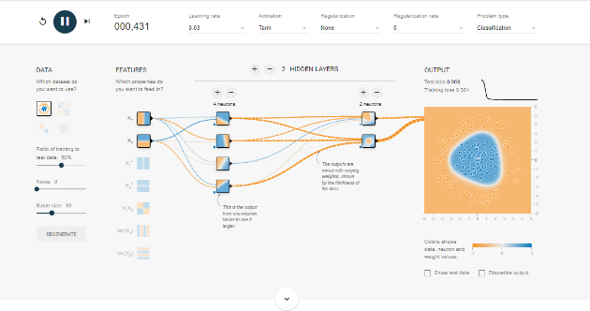

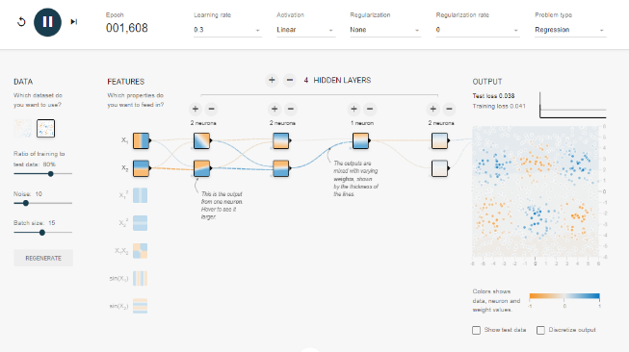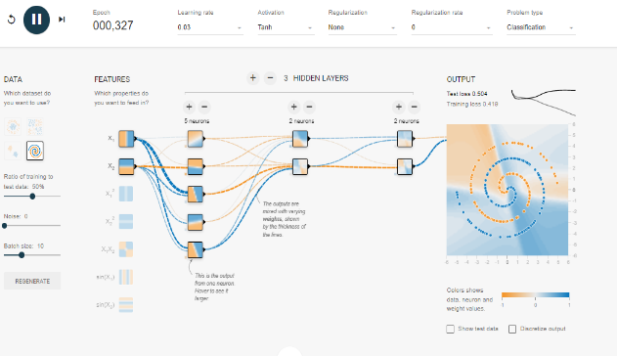

[1]

The learning rate is a setting that controls how fast the network changes its values during training. The learning rate controls how quickly the network updates its internal values, such as weights and biases, during training. A high learning rate can make the network learn quickly, but it might also miss the best solution. A low learning rate makes the network learn more slowly, but it can help find a more accurate solution. [2]

At first, I didn’t know that the datasets were predetermined, but after a while, I noticed that the icons on the left represented the datasets. The library used in this network was designed to be used in TensorFlow visualization. By experimenting with different neural network configurations on TensorFlow Playground, we can gain a deeper understanding of how various parameters affect network performance. TensorFlow Playground is a fun way to play around with neural networks and see how different functions affect their performance. Changing things, like the number of neurons, activation functions, learning rate data rate, and dataset all alter performance, results, and accuracy. Neural networks are a cool and powerful tool. By understanding how they work and experimenting with them, people can create interesting results.

Reference

"TensorFlow Playground." TensorFlow, <https://playground.tensorflow.org/#activation=tanh&batchSize=10&dataset=circle&regDataset=reg-plane&learningRate=0.03&regularizationRate=0&noise=0&networkShape=4,2&seed=0.31733&showTestData=false&discretize=false&percTrainData=50&x=true&y=true&xTimesY=false&xSquared=false&ySquared=false&cosX=false&sinX=false&cosY=false&sinY=false&collectStats=false&problem=classification&initZero=false&hideText=false>. Accessed 10/02/2024. [1]

McManus, Patricia. Patricia McManus Profile. Speak-to.ai, [https://hey.speak-to.ai/patricia-mcmanus. Accessed 10/02/2024](https://hey.speak-to.ai/patricia-mcmanus.%20Accessed%2010/02/2024). [2]